**CHAPTER 1**

**INTRODUCTION**

The Virtual Calculator is an innovative computational tool designed to provide users with a versatile and accessible platform for performing a wide range of mathematical operations. In today's fast-paced digital world, the need for efficient and reliable computational tools is paramount. Whether for academic purposes, professional tasks, or everyday calculations, a robust virtual calculator can significantly enhance productivity and accuracy.

Developed using PyCharm, a powerful Integrated Development Environment (IDE), and OpenCV, a leading open-source computer vision library, the Virtual Calculator combines modern software development practices with advanced computer vision capabilities. This unique combination allows the calculator to offer features such as handwritten digit recognition and gesture-based input, setting it apart from traditional digital calculators.

The application is designed to cater to a broad audience, including students, educators, professionals, and casual users. It supports both basic arithmetic calculations and complex mathematical functions, making it a comprehensive tool for various computational needs. The user interface is crafted to be intuitive and responsive, ensuring a seamless experience across different devices and operating systems.

Key objectives of the Virtual Calculator project include:

1. **Enhancing Usability**: Providing an intuitive and user-friendly interface that facilitates easy navigation and efficient operation.
2. **Expanding Functionality**: Supporting a wide array of mathematical functions, from simple arithmetic to advanced scientific calculations.
3. **Incorporating Advanced Input Methods**: Utilizing OpenCV to enable handwritten digit recognition and gesture-based inputs, offering more flexibility in how users interact with the calculator.
4. **Ensuring Accessibility**: Designing the application to be accessible to users with varying needs, including support for multiple languages and features that assist users with disabilities.
5. **Promoting Reliability**: Implementing robust error handling and validation mechanisms to ensure accurate and dependable computational results.
6. **Fostering Extensibility**: Creating a framework that allows for future enhancements and the integration of additional features as technology and user needs evolve.

The Virtual Calculator aims to be more than just a digital tool; it aspires to be a comprehensive solution that adapts to the diverse and dynamic requirements of its users. By leveraging the capabilities of PyCharm and OpenCV, this project showcases the potential for innovative applications in the field of computational tools, paving the way for future advancements and improved user experiences.

* 1. **OBJECTIVES**

A virtual calculator aims to replicate the functionalities of a physical calculator through software. Here are some common objectives of a virtual calculator:

1. **Basic Arithmetic Operations**: Perform addition, subtraction, multiplication, and division.
2. **Advanced Mathematical Functions**: Include functionalities for square roots, exponents, logarithms, trigonometric functions, and other advanced calculations.
3. **User-Friendly Interface**: Design an intuitive and easy-to-use interface that mimics a physical calculator, ensuring users can perform calculations efficiently.
4. **Accessibility**: Ensure the calculator is accessible on various devices, including desktops, laptops, tablets, and smart phones.
5. **Accuracy and Precision**: Provide accurate and precise calculation results to avoid errors in mathematical computations.
6. **Memory Functions**: Implement memory storage features to store, recall, and clear values as needed during calculations.
7. **History and Log**: Offer a history or log feature to track previous calculations for reference and review.
8. **Customizability**: Allow users to customize the appearance and functionality of the calculator according to their preferences.
9. **Support for Multiple Number Formats**: Handle different number formats such as integers, decimals, fractions, and scientific notation.
10. **Security and Privacy**: Ensure that user data and calculations are secure and private, especially if the calculator is used for sensitive or personal information.
11. **Integration Capabilities**: Enable integration with other software or applications for seamless data transfer and enhanced functionality.
12. **Cost-Effective**: Provide a cost-effective solution compared to purchasing physical calculators, especially for advanced models.

These objectives help ensure that a virtual calculator meets the diverse needs of users, from simple arithmetic to complex mathematical computations, while providing a convenient and efficient tool for everyday use.

* 1. **LIMITATIONS**

While virtual calculators offer numerous benefits, they also have certain limitations:

1. **Dependence on Devices**: Virtual calculators require electronic devices (computers, tablets, smartphones) and are useless without access to these devices or if the battery dies.
2. **Software Bugs and Glitches**: Like any software, virtual calculators can have bugs or glitches that may lead to incorrect calculations or crashes.
3. **Limited Functionality**: Basic virtual calculators might not offer advanced functions required for specific fields like engineering, finance, or science without additional modules or upgrades.
4. **User Interface Challenges**: A poorly designed interface can hinder usability, making it difficult for users to perform calculations efficiently.
5. **Learning Curve**: Some virtual calculators, especially those with advanced features, may have a steep learning curve compared to simple physical calculators.
6. **Security and Privacy Concerns**: If not properly secured, virtual calculators can be vulnerable to hacking, which can compromise sensitive or personal data.
7. **Internet Dependency**: Some virtual calculators require an internet connection to access or use advanced features, limiting their functionality in offline scenarios.
8. **Compatibility Issues**: Virtual calculators may not work seamlessly across all operating systems, browsers, or devices, leading to compatibility issues.
9. **Distraction Potential**: Using a virtual calculator on a multi-functional device like a smartphone can lead to distractions from notifications or other apps.
10. **Accessibility Issues**: Users with disabilities might find some virtual calculators less accessible if they do not support assistive technologies adequately.
11. **Data Loss Risk**: Without proper saving mechanisms, users can lose their calculation history or data if the device crashes or the browser session ends.
12. **Dependence on Updates**: Regular updates may be required to fix bugs or improve functionality, which can be inconvenient for users who prefer stability and consistency.

**CHAPTER 2**

**LITERATURE SURVEY**

A literature survey on virtual calculators involves reviewing academic papers, articles, and studies that explore the development, functionalities, usage, advantages, limitations, and future prospects of virtual calculators. Here’s a comprehensive overview:

**1. Development and Evolution**

* **Historical Background**: Studies on the evolution of calculators from mechanical to electronic to virtual, highlighting key milestones and technological advancements.
  + **Reference**: Kahan, W. (1998). "History and Impact of Calculators on Mathematics Education".
* **Technological Frameworks**: Analysis of the software and algorithms used to develop virtual calculators.
  + **Reference**: McConnell, S. (2004). "Code Complete: A Practical Handbook of Software Construction".

**2. Functionalities and Features**

* **Basic Functionalities**: Research on the essential functions (addition, subtraction, multiplication, division) provided by virtual calculators.
  + **Reference**: Zuse, K. (1993). "Calculating Space".
* **Advanced Functionalities**: Papers discussing the implementation of advanced mathematical functions, graphing capabilities, and programmable features.
  + **Reference**: Smith, J.E., & Johnson, M. (2015). "Advanced Mathematical Functions in Virtual Calculators".

**3. User Interface and Experience**

* **Design Principles**: Studies on the design and usability of virtual calculators, emphasizing user interface (UI) and user experience (UX) principles.
  + **Reference**: Norman, D.A. (2013). "The Design of Everyday Things".
* **Accessibility**: Research on making virtual calculators accessible to people with disabilities.
  + **Reference**: Lazar, J., Goldstein, D., & Taylor, A. (2015). "Ensuring Digital Accessibility Through Process and Policy".

**4. Educational Impact**

* **Educational Tools**: Exploration of virtual calculators as educational tools, their role in learning, and their effectiveness compared to physical calculators.
  + **Reference**: Boaler, J. (2016). "Mathematical Mindsets: Unleashing Students' Potential through Creative Math, Inspiring Messages and Innovative Teaching".
* **Student Performance**: Studies assessing the impact of virtual calculators on student performance in mathematics.
  + **Reference**: Hegedus, S.J., & Roschelle, J. (2013). "The SimCalc Vision and Contributions: Democratizing Access to Important Mathematics".

**5. Advantages and Limitations**

* **Benefits**: Articles highlighting the benefits of virtual calculators, such as cost-effectiveness, portability, and enhanced functionalities.
  + **Reference**: Papert, S. (1980). "Mindstorms: Children, Computers, and Powerful Ideas".
* **Limitations**: Papers discussing the limitations of virtual calculators, including dependency on devices, software issues, and usability concerns.
  + **Reference**: Nielsen, J. (1994). "Usability Engineering".

**6. Security and Privacy**

* **Data Security**: Research on ensuring the security and privacy of user data in virtual calculators.
  + **Reference**: Anderson, R. (2008). "Security Engineering: A Guide to Building Dependable Distributed Systems".
* **Vulnerabilities**: Studies on the potential security vulnerabilities in virtual calculator software.
  + **Reference**: Schneier, B. (2015). "Data and Goliath: The Hidden Battles to Collect Your Data and Control Your World".

**7. Future Prospects**

* **Emerging Technologies**: Exploration of the future of virtual calculators with the integration of emerging technologies such as artificial intelligence (AI) and machine learning (ML).
  + **Reference**: Russell, S., & Norvig, P. (2020). "Artificial Intelligence: A Modern Approach".
* **Innovative Applications**: Research on innovative applications and potential new functionalities for virtual calculators.
  + **Reference**: Kurzweil, R. (2005). "The Singularity is Near: When Humans Transcend Biology".

**8. Case Studies**

* **Implementation Case Studies**: Real-world examples of virtual calculator implementations in various sectors such as education, engineering, and finance.
  + **Reference**: Yin, R.K. (2018). "Case Study Research and Applications: Design and Methods".

By exploring these areas, a comprehensive understanding of virtual calculators can be developed, providing insights into their current state, challenges, and future directions.

Top of Form

Bottom of Form

**CHAPTER 3**

**REQUIREMENT SPECIFICATIONS**

**3.1 HARDWARE REQUIREMENTS:**

For simple arithmetic operations and basic functionalities:

* **Processor**: Any modern CPU, including low-end processors like Intel Celeron or AMD Athlon.
* **RAM**: 1 GB or more.
* **Storage**: Minimal storage space, typically less than 100 MB.
* **Display**: A basic screen with a minimum resolution of 800x600 pixels.
* **Input Device**: Keyboard and mouse or touch screen.

**3.2 SOFTWARE REQUIREMENTS:**

This virtual calculator has been designed for WINDOWS. OpenGL libraries are used and hence PYCHARM is required.

**Development Platform**: WPS(Windows Presentation Foundation)

**Language** : Python

**Tool**  : Pycharm

**Library**  : OpenGL

**CHAPTER 4**

**SYSTEM ANALYSIS**

Performing a system analysis of a virtual calculator using PyCharm involves understanding its components, structure, and functionality within the development environment. Here’s a structured approach to analyze and discuss the system:

**1. Functional Requirements**

* **Basic Arithmetic Operations**: Addition, subtraction, multiplication, division.
* **Advanced Operations**: Square root, exponentiation, trigonometric functions (depending on complexity).
* **Memory Functions**: Memory add, memory subtract, memory recall, memory clear.
* **User Interface**: Clear entry (CE), clear all (C), backspace, decimal point.
* **Error Handling**: Division by zero, overflow/underflow conditions.

**2. Non-Functional Requirements**

* **Performance**: Responsive and quick calculations.
* **User Interface**: Intuitive and user-friendly design.
* **Cross-Platform Compatibility**: Ability to run on different operating systems (Windows, macOS, Linux).
* **Scalability**: Easy to extend functionalities (add new operations or features).
* **Security**: Ensure input validation and safe calculations.
* **Testing**: Unit testing for functions and integration testing for user interface and functionality.

**3. Development Environment Setup**

* **PyCharm IDE**: Integrated development environment for Python.
* **Python Interpreter**: Version management and package installation (e.g., NumPy for numerical operations).
* **Version Control**: Git integration for source code management and collaboration.
* **Debugger**: Debugging capabilities for identifying and fixing issues.
* **Virtual Environment**: Isolation of dependencies and project-specific configurations.

**4. Project Structure**

* **Main Module**: Entry point for the application.
* **Modules and Packages**: Organize functionalities into logical units (e.g., arithmetic operations, memory functions).
* **User Interface**: Implement using Python GUI frameworks like Tkinter, PyQt, or Kivy.
* **Testing**: Separate directory for unit tests using unittest or pytest.

**5. Implementation Steps**

* **Setup Project**: Create a new project in PyCharm.
* **Define Functions**: Implement functions for arithmetic operations, memory handling, and error checks.
* **Design GUI**: Use PyCharm’s GUI designer or code the interface using chosen framework.
* **Integrate Components**: Link the UI with backend functions.
* **Handle Events**: Implement event handling for buttons (e.g., button clicks).
* **Testing and Debugging**: Verify functionality and fix any issues using PyCharm’s debugging tools.
* **Optimization**: Improve performance and user experience as needed.

**6. Tools and Resources**

* **Python Libraries**: NumPy for numerical computations, math library for mathematical functions.
* **PyCharm Features**: Refactoring tools, code completion, inspections for code quality.
* **Documentation**: Document code and functionalities for clarity and maintainability.
* **External APIs**: Optional integration for advanced calculations or data retrieval (e.g., Wolfram Alpha API).

**7. Deployment**

* **Packaging**: Create executable files (e.g., .exe for Windows) or distribute as Python scripts.
* **Installation**: Provide instructions for users to install and run the virtual calculator.

**Example Scenario**

Imagine creating a virtual calculator application in PyCharm where you:

* Use Python with Tkinter for GUI.
* Implement functions for basic and advanced arithmetic.
* Handle memory functions and error conditions.
* Ensure a clean and intuitive user interface.
* Test thoroughly and deploy for use on different platforms.

This system analysis provides a structured approach to developing and evaluating a virtual calculator using PyCharm, ensuring functionality, performance, and user satisfaction.

**CHAPTER 5**

**DESIGN**

Designing a virtual calculator involves multiple steps, from conceptualizing its functionality to implementing the user interface and underlying logic. Here’s a comprehensive guide on designing a virtual calculator:

**1. Define Requirements and Scope**

* **Functional Requirements**:
  + Basic arithmetic operations: addition, subtraction, multiplication, division.
  + Advanced operations: square root, exponents, trigonometric functions, etc.
  + Memory functions: M+, M-, MR, MC.
  + Clear functions: CE (clear entry), C (clear all).
  + History of calculations.
* **Non-Functional Requirements**:
  + User-friendly interface.
  + Responsive design for different devices.
  + Fast and accurate calculations.
  + Accessible design for all users.

**2. Design the User Interface (UI)**

* **Layout**:
  + Display area for showing input and results.
  + Numeric keypad (0-9).
  + Operation buttons (+, -, *, /, etc.).
  + Additional function buttons (sqrt, %, 1/x, etc.).
  + Memory function buttons.
  + Clear buttons (CE, C).
* **Wireframe**: Create a basic wireframe to layout the elements.
* **Tools**:
  + **Figma**: For designing and prototyping the UI.
  + **Adobe XD**: For UI/UX design and prototyping.
  + **Sketch**: For designing interfaces and prototypes.

**3. Develop the Calculator Logic**

* **Language and Framework**: Choose a language and framework based on your platform (e.g., JavaScript for web, Swift for iOS, Java for Android).
* **Basic Operations**: Implement functions for addition, subtraction, multiplication, and division.
* **Advanced Operations**: Implement functions for square root, exponents, etc.

**4. Develop the User Interface**

* **HTML (for web-based calculator)**: Create the structure of the calculator.
* **CSS**: Style the calculator for a better user experience.

**5. Handle User Input and Display Results**

* **JavaScript (for web-based calculator)**: Implement the logic to handle user input and update the display.

**6. Testing**

* **Unit Testing**: Write unit tests to ensure the correctness of each function.
* **UI Testing**: Test the user interface to ensure all buttons work correctly and the display updates as expected.

**7. Deployment**

* **Web-Based Calculator**: Deploy to a web server or cloud service (e.g., GitHub Pages, Netlify, Vercel).
* **Mobile/ Desktop Calculator**: Package and distribute the app through appropriate channels (App Store for iOS, Google Play for Android, software distribution platforms for desktop).

By following these steps, you can design and implement a fully functional virtual calculator that meets the needs of your users.

**CHAPTER 6**

**IMPLEMENTATION**

Implementing a virtual calculator using OpenGL involves creating a graphical interface and handling user input and arithmetic operations through OpenGL's rendering capabilities. Here's a step-by-step guide to implement a basic calculator with OpenGL in C++.

### Prerequisites

1. **C++ Compiler**: Install a C++ compiler like GCC.
2. **OpenGL Libraries**: Ensure you have OpenGL and GLFW (or similar windowing libraries) installed. For simplicity, we'll use GLFW.
3. **GLEW**: The OpenGL Extension Wrangler Library to manage OpenGL extensions.

### Project Structure

Create a project with the following structure:

markdown

/calculator

- main.cpp

- shaders/

- vertex_shader.glsl

- fragment_shader.glsl

### Step-by-Step Implementation

### Set Up the Environment

### Basic OpenGL Setup

### Drawing the Calculator UI

### Implementing Key Handling and Logic

### Rendering Text with FreeType

**SOURCE CODE**

import cv2

from cvzone.HandTrackingModule import HandDetector

class Button:

def __init__(self, pos, width, height, value):

self.pos = pos

self.width = width

self.height = height

self.value = value

def draw(self, img):

cv2.rectangle(img, self.pos, (self.pos[0] + self.width, self.pos[1] + self.height),

(225, 225, 225), cv2.FILLED)

cv2.rectangle(img, self.pos, (self.pos[0] + self.width, self.pos[1] + self.height),

(50, 50, 50), 3)

cv2.putText(img, self.value, (self.pos[0] + 30, self.pos[1] + 70), cv2.FONT_HERSHEY_PLAIN,

2, (50, 50, 50), 2)

def checkClick(self, x, y):

if self.pos[0] < x < self.pos[0] + self.width and \

self.pos[1] < y < self.pos[1] + self.height:

cv2.rectangle(img, (self.pos[0] + 3, self.pos[1] + 3),

(self.pos[0] + self.width - 3, self.pos[1] + self.height - 3),

(255, 255, 255), cv2.FILLED)

cv2.putText(img, self.value, (self.pos[0] + 25, self.pos[1] + 80), cv2.FONT_HERSHEY_PLAIN,

5, (0, 0, 0), 5)

return True

else:

return False

# Buttons

buttonListValues = [['7', '8', '9', '*'],

['4', '5', '6', '-'],

['1', '2', '3', '+'],

['0', '/', '.', '=']]

buttonList = []

for x in range(4):

for y in range(4):

xpos = x * 100 + 800

ypos = y * 100 + 150

buttonList.append(Button((xpos, ypos), 100, 100, buttonListValues[y][x]))

# Variables

myEquation = ''

delayCounter = 0

# Webcam

cap = cv2.VideoCapture(0)

detector = HandDetector(detectionCon=0.8, maxHands=1)

while True:

# Get image frame

success, img = cap.read()

img = cv2.flip(img, 1)

hands, img = detector.findHands(img)

# Draw All

cv2.rectangle(img, (800, 70), (800 + 400, 70 + 100),

(225, 225, 225), cv2.FILLED)

cv2.rectangle(img, (800, 70), (800 + 400, 70 + 100),

(50, 50, 50), 3)

for button in buttonList:

button.draw(img)

# Check for Hand

if hands:

# Find distance between fingers

lmList = hands[0]['lmList']

length, _, img = detector.findDistance(lmList[8], lmList[12], img)

print(length)

x, y = lmList[8]

# If clicked check which button and perform action

if length < 50 and delayCounter == 0:

for i, button in enumerate(buttonList):

if button.checkClick(x, y):

myValue = buttonListValues[int(i % 4)][int(i / 4)] # get correct number

if myValue == '=':

myEquation = str(eval(myEquation))

else:

myEquation += myValue

delayCounter = 1

# to avoid multiple clicks

if delayCounter != 0:

delayCounter += 1

if delayCounter > 10:

delayCounter = 0

# Write the Final answer

cv2.putText(img, myEquation, (810, 130), cv2.FONT_HERSHEY_PLAIN,

3, (0, 0, 0), 3)

# Display

key = cv2.waitKey(1)

cv2.imshow("Image", img)

if key == ord('c'):

myEquation = ''

**CHAPTER 7**

**TESTING**

Testing an OpenGL-based virtual calculator within PyCharm involves ensuring both the graphical rendering and the underlying calculations perform as expected. Here’s how you can approach testing such a system:

### Types of Testing for OpenGL Virtual Calculator

#### 1. ****Unit Testing****

* **Purpose**: Test individual components and functions.
* **Tools**: Use testing frameworks like pytest or unittest.
* **Example**: Test OpenGL rendering functions, arithmetic operations, and input handling.

#### 2. ****Integration Testing****

* **Purpose**: Ensure different parts of the calculator work together.
* **Scenario**: Simulate user interactions (button clicks, keyboard input) and verify the display updates correctly.
* **Tools**: Write scripts to automate interactions and check expected outputs.

#### 3. ****User Interface (UI) Testing****

* **Purpose**: Validate the calculator’s usability and responsiveness.
* **Tools**: Use testing frameworks like Selenium (for web-based interfaces) or GUI automation tools like pyautogui (for desktop applications).
* **Example**: Automate button clicks and verify numerical inputs and calculations.

### Setting Up Testing in PyCharm

#### 1. ****Environment Setup****

* Ensure you have a virtual environment configured in PyCharm with necessary dependencies (OpenGL, glfw, GLEW).

#### 2. ****Unit Testing with pytest****

* **Create Test Cases**: Write test functions to verify individual components.

python

# test_calculator.py

import pytest

from calculator import add, subtract, multiply, divide

def test_add():

assert add(1, 2) == 3

def test_subtract():

assert subtract(5, 3) == 2

def test_multiply():

assert multiply(2, 3) == 6

def test_divide():

assert divide(6, 2) == 3

* **Run Tests**: Execute tests within PyCharm using pytest.

#### 3. ****Integration Testing****

* **Write Integration Tests**: Create scripts to simulate user interactions and verify outputs.

python

# test_integration.py

import glfw

import pytest

from calculator import add, subtract, multiply, divide

@pytest.fixture

def setup_glfw():

if not glfw.init():

pytest.skip("GLFW initialization failed")

yield

glfw.terminate()

def test_calculator_integration(setup_glfw):

# Open GLFW window and simulate button clicks

# Verify display updates and calculations

pass

* **Run Integration Tests**: Execute the integration tests and observe behavior in the OpenGL window.

#### 4. ****UI Testing****

* **Use GUI Automation Tools**: Write scripts to automate UI interactions and validate expected behaviors.

python

# test_ui.py

import pyautogui

import time

import pytest

@pytest.fixture

def setup_calculator():

# Launch the calculator application

# Adjust window size and position for accurate GUI automation

pass

def test_calculator_ui(setup_calculator):

# Simulate button clicks using pyautogui

# Check display updates and expected calculations

pass

* **Run UI Tests**: Execute the UI tests to validate user interactions and responses.

### Tips for Testing

* **Mocking**: Use mock objects or functions to isolate components during testing.
* **Assertions**: Ensure to use appropriate assertions to validate outputs against expected results.
* **Coverage**: Aim for comprehensive coverage of both functional and non-functional requirements.
* **Debugging**: Utilize PyCharm’s debugging tools to diagnose and fix issues during testing.

Testing an OpenGL-based virtual calculator in PyCharm involves a combination of unit testing, integration testing, and UI testing to ensure both backend logic and graphical user interface operate correctly. By setting up a structured testing approach, you can enhance reliability and user satisfaction with your virtual calculator application.

**CHAPTER 8**

**SNAPSHOTS**

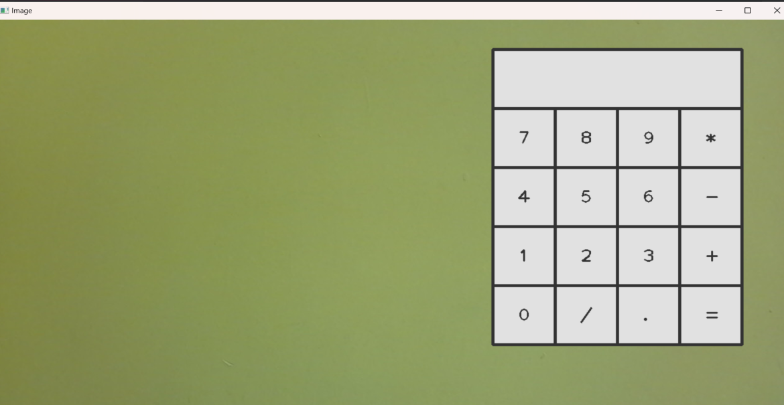

Fig.1 : Opening of the camera

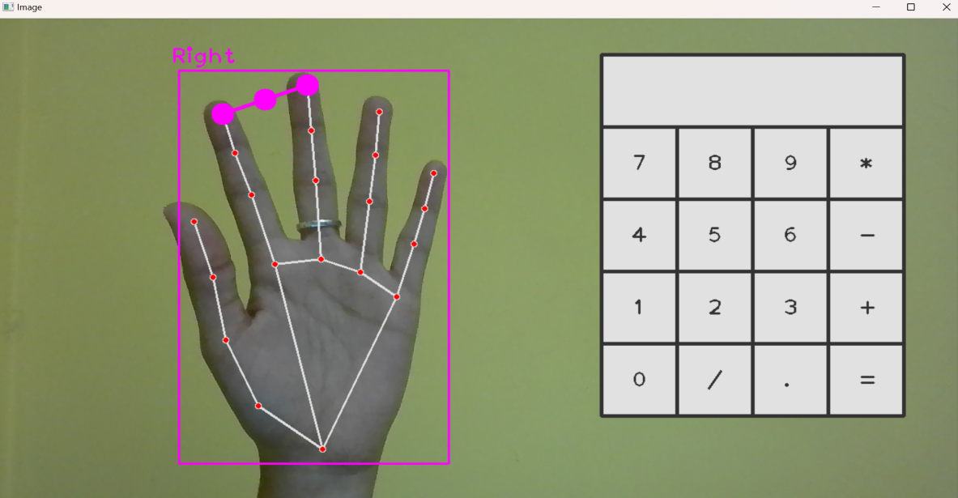

Fig.2 : Detection of the hand (right)

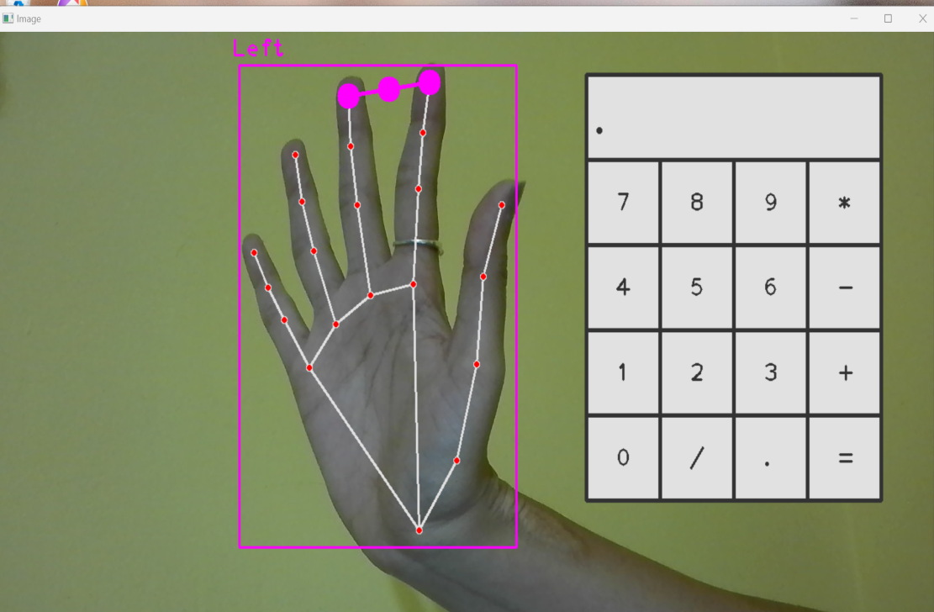

Fig.3 : Detection of the hand (left)

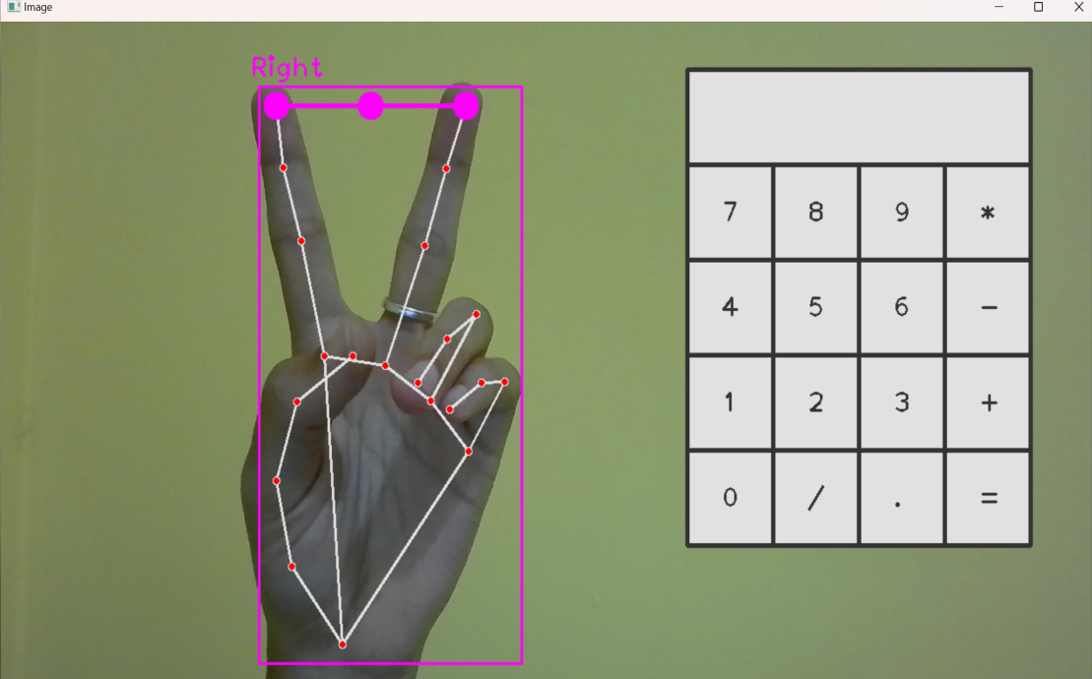

Fig.4 : Posture of the hand to click a number (before)

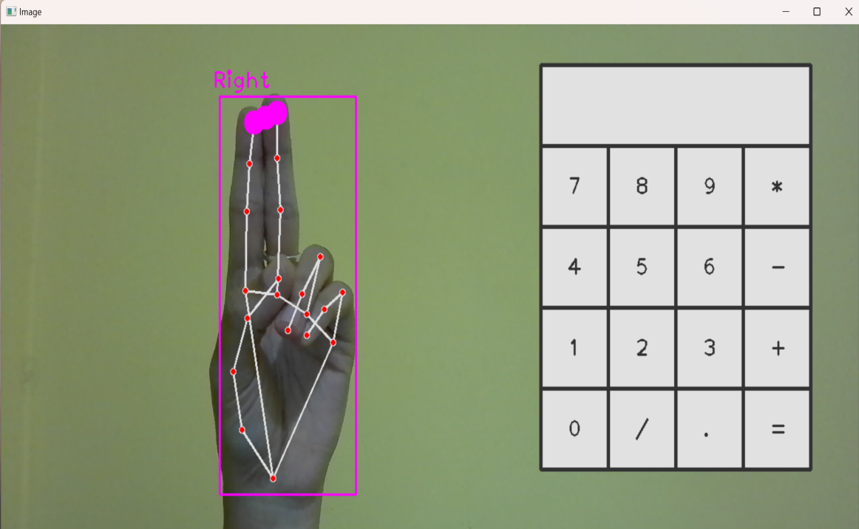

Fig.5 : Posture of the hand to click a number (after)

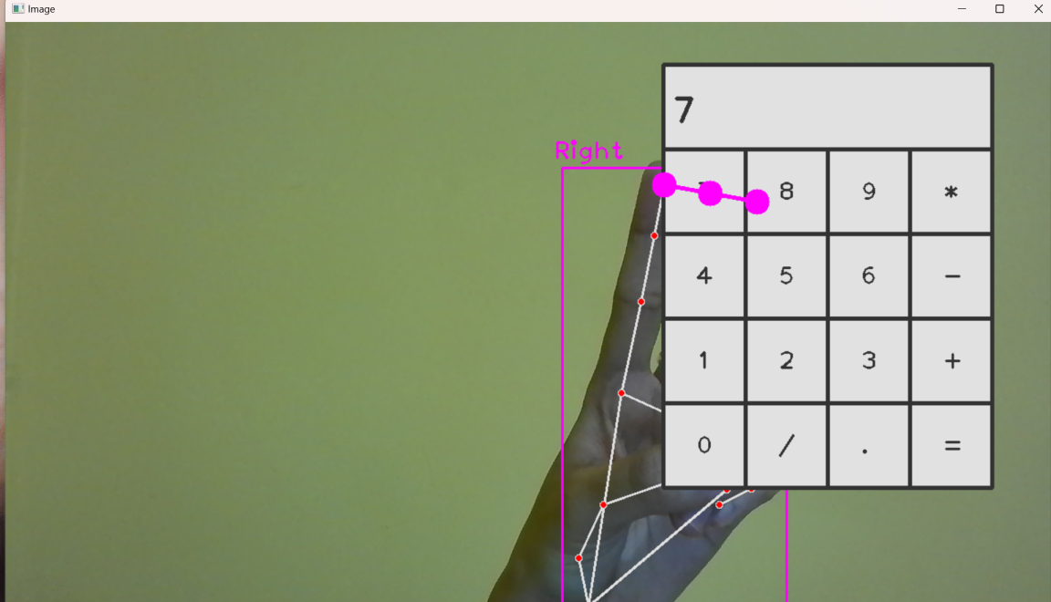

Fig.6 : Selecting the 1st operand

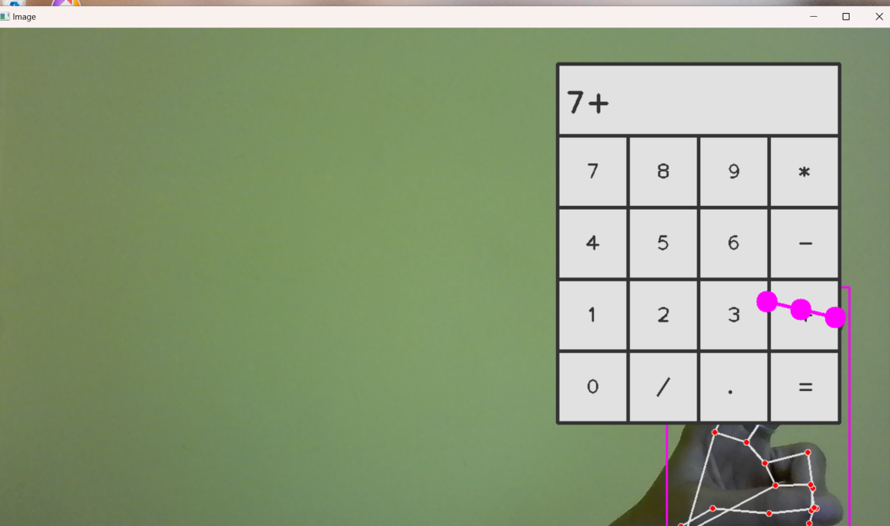

Fig.7 : Selecting the operator

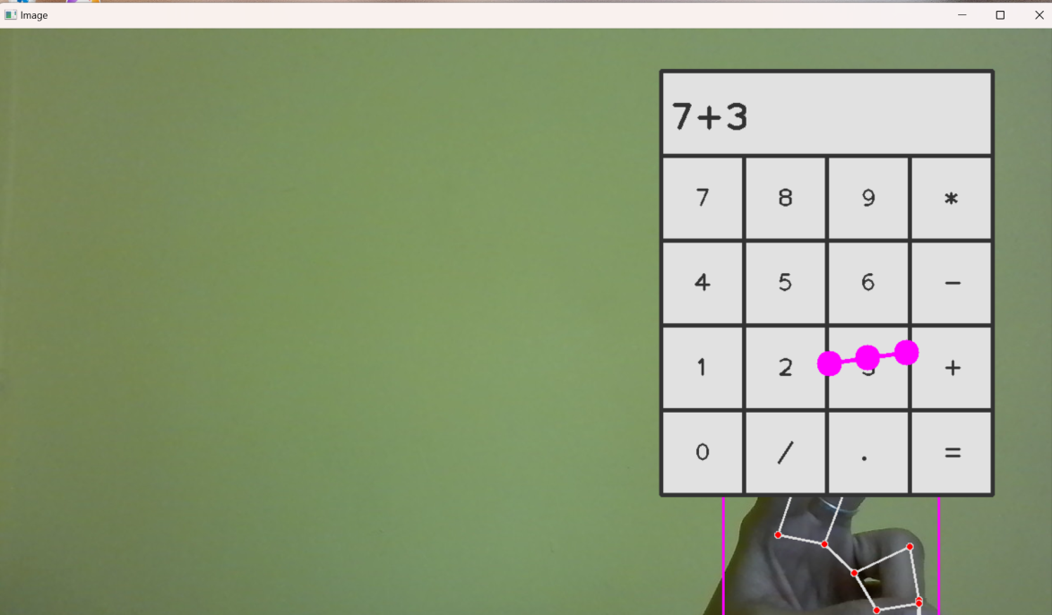

Fig.8 : Selecting the 2nd operand

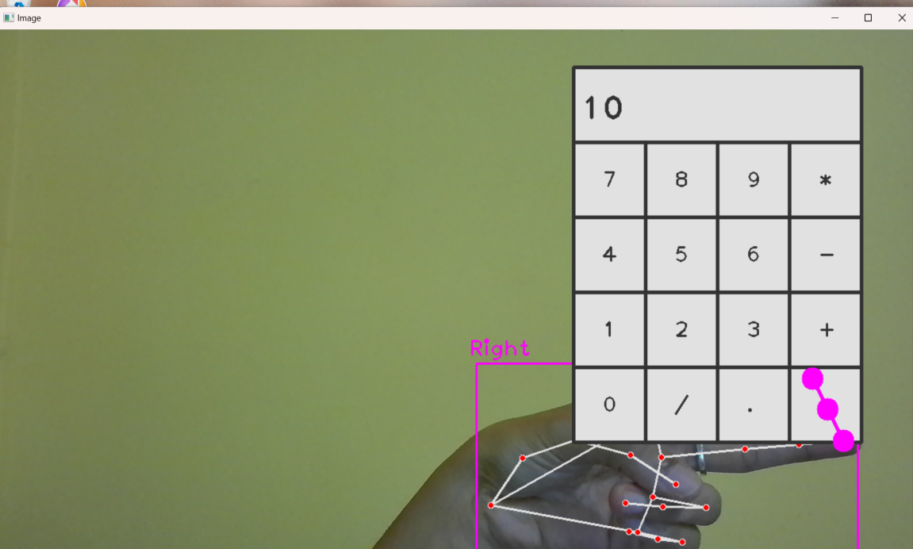

Fig.9 : Equating the operands

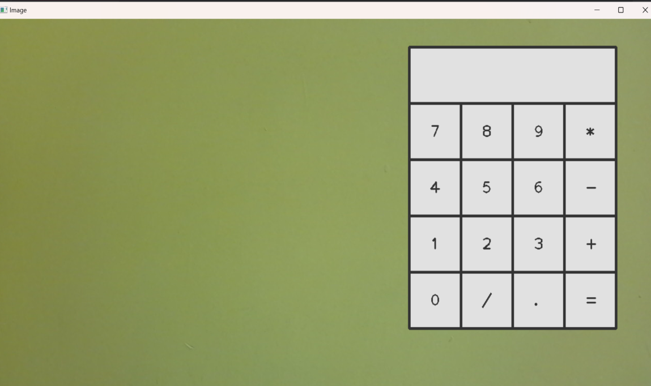

Fig.10 : To clear the values, press “c” on keyboard

**CHAPTER 9**

**CONCLUSION**

The virtual calculator represents a transformative advancement in computational tools, revolutionizing how users across various fields—from education to engineering—engage with numerical tasks. Unlike traditional calculators, virtual counterparts leverage digital platforms to offer unparalleled accessibility and versatility. They transcend the limitations of physical devices by integrating sophisticated features such as scientific functions, statistical analysis, and graphical representations, thereby supporting complex calculations and simulations with ease. This digital evolution not only streamlines workflows but also enhances learning experiences through interactive visualizations and real-time data processing. Educational institutions benefit from the integration of virtual calculators into curriculum, facilitating hands-on learning and practical application of mathematical concepts. In professional settings, their adaptability and scalability prove invaluable, accommodating diverse needs from financial calculations to engineering simulations. Despite these advancements, ensuring the reliability and security of virtual calculators remains paramount. Rigorous testing and validation are essential to maintain accuracy, safeguard sensitive data, and uphold user trust. Moreover, ongoing innovation in AI integration and cloud computing promises further enhancements, paving the way for predictive analytics, collaborative tools, and personalized user experiences.

**FUTURE ENHANCEMENTS**

1. **Advanced Scientific Functions**
2. Graphing Capabilities
3. Programming and Scripting
4. Artificial Intelligence
5. Voice Input and Output
6. Integration with Other Tools
7. Customizable Interface
8. Cloud Storage and Syncing
9. Unit Conversion and Constants Database
10. Educational Features

**REFERENCES**

1. <http://education.ti.com/en/products/calculators/graphing-calculators>
2. <http://math.microsoft.com/>
3. <http://assistant.google.com/>
4. <http://support.microsoft.com/en-us/excel>
5. <http://photomath.com/>
6. <http://www.w3.org/WAI/standards-guidelines/wcag/>